Task1:
In the source files provided in lab7Code folder, the code skeletons for a simple, table-based application are provided. Class ScheduleGUI is the main program that constructs the GUI. It acts also as caretaker. Class ScheduleTableModel is a subclass of DefaultTableModel that stores the data of a table. Class TableMemento is a memento class for tables.
- Provide the following improvments:
- Complete the classes ScheduleGUI, ScheduleTableModel, and TableMemento.
- Refactor the application so that the memento class becomes an inner class of ScheduleTableModel.
- Add a "Save as.." feature to the application that allows to save the memento object in a file. Add also a "Load.." feature to the application.
- Create a UML class diagram showing your design.

Task 2:
In the source files provided in lab7Code folder, the RemoteDeviceV1.java implements states of a media player without using a State pattern. TestDrive.java is to test RemoteDeviceV1.java.
With the State pattern, we get the system with State.java, Playing.java, Paused.java, Stopped.java, and RemoteDevice.java.
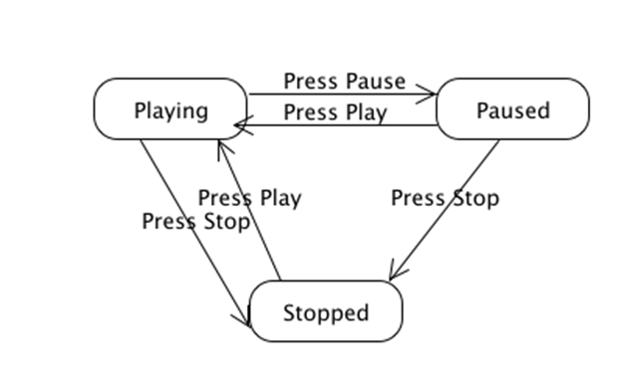
- Modify the program TestDrive.java so that it used the new RemoteDevice class.
- Consider if we want to add a rewind button (this also sets the position back to 0.): Modify the program so that it allows a Rewind state as well as a pressRewind() transition. However, notice that you can only transition to Rewind from Stopped. (Don't forget to set the position back to zero!)
You also have to consider what state to transition to from Rewind. (In other words, once you have rewound the media, what can you do next?) There are a few different ways of accomplishing this, however one strategy is to consider the following hint: It is ok to have a transition from one state to the next that requires no action on the user part (they don't have to press any buttons.)
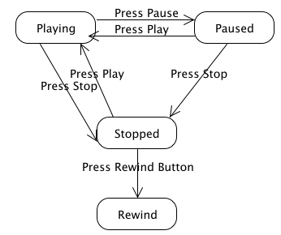
- What if we added a locked feature to our remote? When the remote is locked, we cannot press any buttons (except to unlock it.) Modify your program so that it provides for a lock.
- Create a UML class diagram showing your design.

